**Walk 46 Walks around Luston Group Parishes 2**

Last walked in September 2018

**Description.** 6km (3.7 miles). This walk takes us out of the village and into the beautiful surrounding countryside. It is mainly to go thru fields, crossing several streams and the railway line, with a short stretch along Eye Lane.

**Start.** Balance Inn, Luston. Explorer Map 203 Grid 486633.

**Directions from Whitecross Roundabout** (Turn milometer to zero). Take the A4110 Canon Pyon (Three Elms road) for 1 mile and TR at the traffic lights onto the A4103 to Worcester (Roman road). TL at the first roundabout (2 miles), onto the A49 to Leominster. Go straight across the next two roundabouts (9.5 miles then 12.5 miles) on the A49 heading towards Shrewsbury. TL at the next roundabout (13.3 miles) onto the A44 to Leominster. At 13.8 miles TR onto the B4361 towards Richards Castle. At 15.8 miles you enter Luston, and at 16.4 miles you TL and park somewhere along Townsend Park road.

**1. Townsend Park.** Walk back to the main road and TR. Walk on the L side of the road. 50m past the Balance Inn, and opposite the Methodist Chapel you TL at a footpath sign. Go thru a gate and along an enclosed track and into a small field, keeping to the hedge on your L, to reach the bottom corner. Go thru a gap in the hedge into **F1** and walk straight across, heading towards a large hedgerow tree by a gap in the hedge. Go thru the gap and continue across **F2** to cross a footbridge over a stream into **F3**. Follow the hedge on the L to cross a stile, then a railway line and over another stile into **F4**. Continue straight ahead to go thru a gate then across a farm track to go thru another gate into a small field **F5**. Walk straight across; two thirds of the way across you TL to walk to the hedgerow where you go thru a small metal k/gate into a small field. Go across the field and thru another k/gate into the the churchyard, (tall brick wall on the L). Continue on thru churchyard to reach the Lychgate.

**2. Eye, St Peter & St Paul Church. *Though not necessarily remarkable, Eye church is designated as a grade I listed building and is lovely example of a typical English country church.*** Thru the Lychgate and TL, follow drive to Eye Lane. TL and follow the lane, past the old railway station (now a private house) and over the railway bridge. When the lane starts bending L, and just before Cowley Village Hall that’s a little further on (R), you TR (footpath and way marker signs), to go thru a gap in the hedge and on thru a small shrub field into **F6**.

**3. Hedge Gap.** Keep to the hedge on your L, and when it turns sharp L you continue straight on across the field, heading towards some buildings and a gap in the tall hedge in front of you. Cross over a stile, then a tarmac drive to cross over another stile and walk along an enclosed grassy track, to cross over a stile into **F7**. Continue along the L field edge to go thru a k/gate into **F8**. Continue along the L field edge to cross over a wooden footbridge and onto a road.

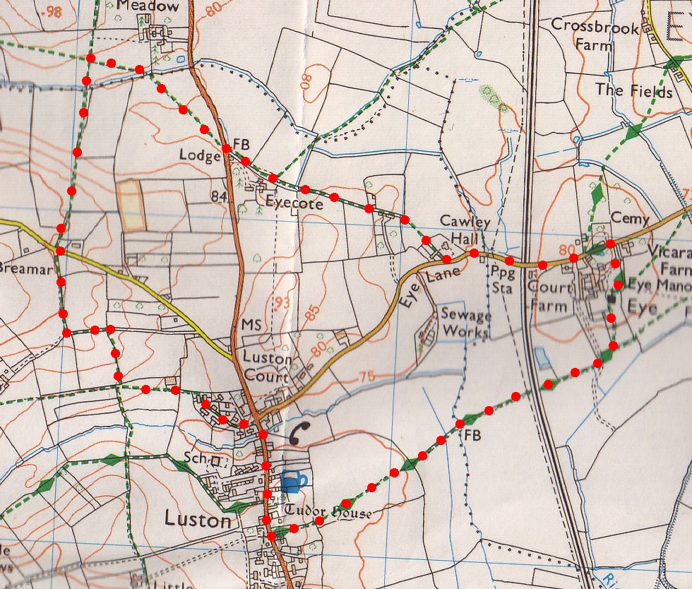**4. Footbridge.** Go thru k/gate on the opposite side of road and into **F9**. Turn half R and go diagonally across this field, heading towards the last lone tree on the R, to cross a stile and footbridge into **F10**. Turn half L and continue across this field to go thru a gate into **F11**. TL (ignore waymark pointing R) and follow fence to the bottom of the field. Cross over an earthy bridge over a stream, and go thru a k/gate into **F12**. Continue directly up the middle of the field to go thru a k/gate in the hedge at the top of the hill. Follow an enclosed narrow hedged path going thru a small metal gate and onto Yarpole Lane.

**5**

**4**

**3**

**2**

**5. Yarpole Lane.** Cross the road, follow farm road opposite. As the road bends R and just after a traffic bump, (and by chicken sheds) turn sharp L into **F13**. Follow R field edge and after 100m you TR to go thru the hedge and into **F14**. Walk straight across this field towards large oak tree, and past it to cross a stile into **F15**. TL and walk along L field edge, across the concrete and along a farmers track ahead to reach Townsend Park Road. Follow road thru houses to car.

**1**